Pupil Premium Strategy Statement 2018-19

1. Summary Information
School | Our Lady & St. Hubert’s Catholic Primary
Academic Year | 2018-19 | Total PP budget | £73,540.00  Inc 11,500 LAC | Date of most recent PP Review | September 2018
Total number of pupils | 365 inc pre-school  337 exc pre-school | Number of pupils eligible for PP | 47  plus 5 post LAC | Date for next Strategy Review | September 2019

- Current attainment (EYFS to current Year 6)
 | Pupils eligible for PP (your school) | Pupils not eligible for PP (national average)
% achieving expected standard or above in reading, writing & maths | 50%
% making expected progress in reading (as measured in the school) | 92%
% making expected progress in writing (as measured in the school) | 92%
% making expected progress in mathematics (as measured in the school) | 98%

Cohort 18 – Previous Year 6 attainment (as published on ASP)
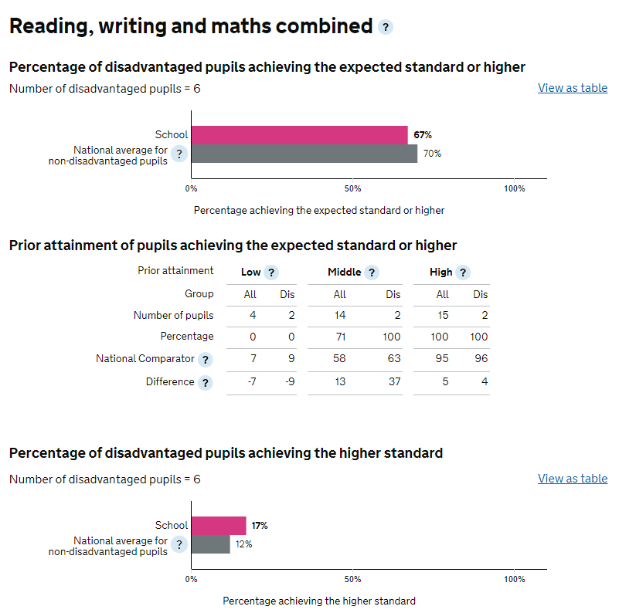
Cohort 18 – Previous Year 6 progress (as published on ASP)

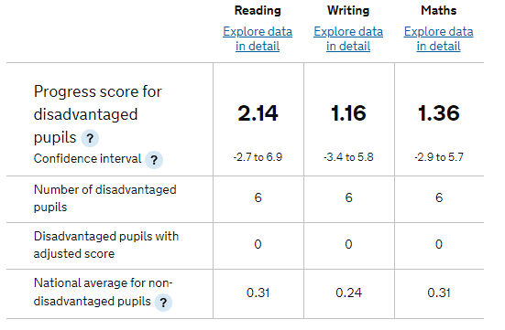

2. In addition to those strategies which proved successful in previous years, 2018-9 includes:
A | Targeted support from Safeguarding and Inclusion Lead, with easily accessible, targeted support to diminish barriers to learning – including improving attendance of target pupils. Reduce the number of pupils with attendance below 95%. Target pupils to make good progress and begin to close the attainment gap. Target of 98% this year.
B | A contracted counselling service to targeted children to ensure their continual mental health and wellbeing. Specific work on SEMH to ensure attendance, wellness and personalised barriers to learning are recognised, targeted and overcome.
C | The deployment of a reading teaching assistants, increasing reading skills and improving reading outcomes in KS1 and KS2.
D | The introduction and implementation of an integrated school 360 system to enable inclusive learning in school, and develop enhanced home learning accessibility and opportunity.
E | Implementation of a broad 6C’s curriculum to engage deeper thinking, and consequently learning.
F | Children who are not disadvantaged or for whom pupil premium funding will not start being received until after April 2019 may also be included in intervention work to maximise readiness and capacity to learn, the efficient use of funds and maximise impact on pupil outcomes.

2. Barriers to educational achievement
Internal barriers
A | Less PP children achieve greater depth in core subjects, and combined with increased numbers of pupils with speech and language issues including EAL.
B | Vacancy for substantive Outstanding Early Years Leader, Reception Class Teacher with change to whole school phonics (Ruth Miskin Literacy) lead.
C | Historical narrowing of curriculum, reducing engagement of children in broader subjects.
D | High proportion of pupils eligible for PP have irregular reading habits and fixed mindsets. This slows progress down year on year due to low aspirations.
External barriers
E | Safeguarding, social and emotional barriers to learning
F | Attendance and punctuality of targeted groups of pupils
G | Social and economic factors including life experiences, EAL and ability of families to support
H | Accessibility and breadth of physical, artistic and creative experiences outside of school

3. Outcomes |  | Success criteria
In-school barriers
A | Less PP children achieve greater depth in core subjects, and combined with increased numbers of pupils with speech and language issues including EAL. | 75% pupils achieve GLD in EYFS overall  Increased hours of Senior Speech and Language NHS specialist - TAs trained and supported by LA provision and Senior S&L specialist to implement SL action plans. Pupils achieve speech & language milestone targets.  PP pupils receive additional phonic and language input where red or amber on Wellcomm screening leading to improved attainment on reassessment.  Small targeted groups of maximum 10 pupils taught by highly trained staff to deliver synthetic phonics programme. Additional training of preschool staff and new RML lead to maximise learning prior to Reception class.  SENCO and Safeguarding and Inclusion Lead liaise with parents to ensure LA provision is accessed.  87% pupils achieve expected Y1 phonics test
B | Vacancy for substantive Outstanding Early Years Leader, Reception Class Teacher with change to whole school phonics (Ruth Miskin Literacy) lead. | Deputy Head and Early Years SLE named as temporary Reception class teacher and early years lead. Targeted children making good progress and able to break through barriers to learning, enabling smooth transition into KS1 and high parental engagement.  Recruitment and training of new RML lead to maximise effectiveness of phonics teaching and enhance targeted PP progress.  New RML lead trained in Nursery RML, ensuring high quality early years provision, and school readiness in newly established pre-school.  Healthy initiatives ensure children are healthy and well in their early years through enhanced provision such as sports coaching and food provision.
C | Historical narrowing of curriculum, reducing engagement of children in broader subjects. | Implementation of 6C’s, Project Based Curriculum enabling relevant cross-curricular, deeper thinking curriculum encapsulating a broader curriculum delivered by highly trained staff.  Teacher appraisal defines clear responsibility of subject leaders to monitor, analyse and report to Governors on the progress of targeted children in broader curriculum areas. Pupil Premium tracking systems include the barriers to learning in broader curriculum areas, interventions and progress.  Pupil Voice reflects children’s engagement in PBL and 6C’s – showing greater personal aspirations.  Pupil Progress is rising in broader curriculum areas.
D | High proportion of pupils eligible for PP have irregular reading habits and fixed mindsets. This slows progress down year on year due to low aspirations. | Allocated TA time to hear daily readers across the school for eligible pupils, supporting phonics and comprehension.  Improved reading outcomes in KS1 and KS2.  The introduction and implementation of an integrated school 360 system to enable inclusive learning in school, and develop enhanced home learning accessibility and opportunity.  Targeted children have access to Britannic Encyclopaedia through teacher, individual in school and home access.  Pupil voice reflects children’s motivation to read, as 6C’s curriculum and PBL provide greater relevance – engaging pupils deeper in their learning and showing a greater motivation to read and higher self-aspirations.  PBL showcase events raise children and parental aspirations through environmental and community engagement with ‘Citizenship’ at the heart of the School Improvement Plan.
External barriers
E | Safeguarding, social and emotional barriers to learning | Contracted counselling service to targeted children to ensure their continual mental health and wellbeing. Specific work on SEMH to ensure attendance, wellness and personalised barriers to learning are recognised, targeted and overcome.  Close tracking of self-esteem and confidence, plus improved behaviours for lunch time and gauge emotional states of individuals most in need of designated adults. Includes tracking of MyConcerns for known pupils and personalised responses.  Continual support of Safeguarding and Inclusion Lead (previous title Learning Mentor) coordinates services for targeted children – bringing together harmonious support for targeted children which results in continually high attendance, close parental relationships and at least sustained progress across the curriculum.  Parents have daily, easy access to Safeguarding and Inclusion Lead (previous title Learning Mentor) as she is on the school gate each morning to meet and greet. Known, established person of trust ensuring high level engagement with parents. Greater percentage of staff on playgrounds at designated times – building relationships between home and school.
F | Attendance and punctuality of targeted groups of pupils | Attendance continues to be 96.8% or more  PP attendance improves 95.3% to 96%
G | Social and economic factors including life experiences, EAL and ability of families to support | Pupil voice and triangulated information shows pupils are happy at school, have access to a wide range of communication methods which ensure inclusion, access a wide range of experiences that may be beyond their family’s reach.  Parents confident in accessing school for support.  Children in safe and SEM supportive households.
H | Accessibility and breadth of physical, artistic and creative experiences outside of school. | Allowing targeted children the ability to play a tuned musical instrument for a year, learning to read music, focus and concentration improvements and develop a love of music.  Access to school trips, outings and experiences which broaden the experiences of targeted children.  PBL and 6C’s curriculum fires greater self-aspiration and engagement in community initiatives beyond school.

4. Plan including actions, expenditure and review dates 2018-19

Chosen action/approach | What is the evidence & rationale for this choice? | How will you ensure effective implementation? | Staff Lead | Cost | Termly review
A,C,D,E,F,G,H  Significant development of Learning Mentor role to Safeguarding and Inclusion Lead (SIL) to enable coordinated services for children encapsulating SEMH and family support, attendance and wellbeing.  Safeguarding and Inclusion Lead to be on gate daily, speaking with parents, monitoring punctuality and following up absence with first day calling – easily accessible to parents and professionals on designated phone number.  Safeguarding and Inclusion Lead role now includes close liaison with Designated Teacher for LAC and attendance at LAC/PEP events. | Services for targeted children are coordinated and provide a holistic perspective on progress and well-being.  SIL is easily accessible to children, parents and professionals ensuring rapid response to issues and proactive support which has a positive impact at the time of need.  Attendance and punctuality is rigorously tracked, with punctuality issues known – services to improve coordinated and relationships with families harnessed to bring about better outcomes for children.  LAC children receive coordinated care with professionals working in partnership to provide targeted and networked support. | Pupil and Parental Voice  Reports to Governors and links with relevant nominated Governor.  Tracking of attendance percentages and triangulated action.  Analytical reports showing benefits of networking, such as MyConcerns and EPEP.  SIL job description clarifying role with appraisal managed by HT, regular updates and weekly meetings between HT and SIL.  Delegation of specific tasks connected to need.  Feedback from professionals such as counselling support.  Outcomes for pupils and families – academic, social and emotional.  Monitoring of attendance of all groups to be national average or better. | Claire Channa | £36,967 | 18 December 2018  9 April 2019  9 July 2019
A, B, C, D, E  Promotion of HLTA to Unqualified Teacher with responsibility of early word reading (RML).  Additional training and regular coaching and mentoring for teachers, teaching assistants for phonics in EYFS/KS1 to provide smaller groups and catch up tuition.  Training for new staff on phonics teaching including RML lead and pre-school staff.  RML implemented in new pre-school opened in September 2018. | Early Years Research such as Bold Beginnings emphasises importance and value of early communication, phonics and language input.  HLTA previously coordinated KS1 library services to a high standard – extension of role views reading holistically for children and parents.  Sutton report: 1:1 tuition and oral language interventions effective.  Previous success of RML in 2017-2018 values investment in extending services wider to new pre-school and ensuring coordinated approach through school remains. | Fortnightly RML meetings.  Coaching and mentoring by RML Lead.  Staff feedback.  Monitoring of data.  Monthly monitoring of provision and outcomes by SMT, phonics lead and learning mentor.  Gap closes between PP and non-PP with rigorous focus on PP achieving greater depth. | Naomi Handy | From budget | 18 December 2018  9 April 2019  9 July 2019
A, B, C, D, E, F, G, H  Deputy Head (SLE in Early Years) to fill role of Early Years Lead, Reception Class Teacher whilst recruitment strategy in place.  Pre-school opened in September 2018. | Early Years Research and Governmental drives recognise importance of high quality early education.  Deputy Head is also SLE in Early Years to maintain and improve quality of early education providing seamless transition and firm foundation as children move into Year 1. | Gap monitored between PP and non-PP with rigorous focus on PP achieving greater depth in both pre-school and reception classes, ensuring rigour is continued into KS1.  Early word reading (RML) strategy at least maintains percentage of ELG in Speaking, Reading and Writing.  Improved quality of early years provision, preparing children to demands of Year 1 curriculum. | Michelle Crawford | From budget | 18 December 2018  9 April 2019  9 July 2019
D, E, F,G,H  Use of EPEP and My Concern behaviour/safeguarding system | Achievement of Sandwell’s Wellbeing Charter Mark in 2018 reflects high quality provision – to continue and further develop.  EPEP launched by LA in Autumn 2018 – SIL and DT actively use system to ensure coordinated services and effective systems.  Knowledge that emotional well-being impacts on attainment and family ability to support.  This system helps identify concerns and track provision, involving all staff in discussion of pupils’ needs and so removing barriers to learning  Reduces staff time reporting and tracking incidents, freeing up for teaching and learning – all staff trained and using actively. | My Concern records  EPEP implementation and training attended.  SIL and LAC DT to coordinate  pupil records.  All staff use MyConcerns.  Raised awareness of role of LAC DT and responsibilities by all staff. | SIL – Claire Channa  DT – Michelle Crawford | From budget | 18 December 2018  9 April 2019  9 July 2019
A,C,D,E, F, G, H  Targeted support for Year 5 / 6 incl. To improve pupil engagement in their learning and pupils knowing their next steps through targeted tuition from booster book, personalising learning and setting targets which are developed back in class. | Sutton Trust evidences impact of 1:1 and small group provision  Impact in 2017-8  Disadvantaged pupils and those with language needs may have improved access to resources and appropriate adult support through this provision coming from school, impacting on progress and attainment. | Attendance generically and additional booster sessions.  Attendance of parents at Y5/Y6 parent engagement evenings including children’s conferencing and SATS information events.  Pupil progress and attainment records.  Key Stage Meetings and SLT meetings.  Termly pupil progress meetings | Head teacher | From budget. | 18 December 2018  9 April 2019  9 July 2019
A, G  Provision of milk/fruit/toast/other items where pupils are in need | Research shows that pupils benefit if they are hydrated and nourished and have the things they need for school.  Pupils from disadvantaged backgrounds may not have these benefits as standard. | SIL to monitor and approve uptake. | SIL | Free School Meals £12,252  Milk and Snacks £1000 | 18 December 2018  9 April 2019  9 July 2019
A, C, D, E, F  Contracting of external Counselling Services. | New pro-active initiative, responding to needs of children.  Extension to already achieved Local Authority Wellbeing Charter Mark.  Governmental and school commitment to children and families SEMH. | Attendance of targeted children.  Progress of targeted children is at least on flight track with sustained progress through trickier times.  Pupils become effective learners in classroom.  Pupils are better able to self-regulate, drawing on learned strategies and parental engagement. | Headteacher through contracted services. | From £19,001 | 18 December 2018  9 April 2019  9 July 2019
A, B, C, D,E,F, G, H  Subsidy of trips or enhancement projects (offering experiences that may otherwise be lacking) e.g. theatre, residentials, swimming, music lessons, clubs | Links between barriers to learning, paucity of language and SEMH.  All pupils have the opportunity to attend a school trip each year.  Evidence shows that participating in some of these activities raises aspiration.  Participation in activities such as music lessons impacts on attainment.  Enrichment broadens horizons and improves physical and emotional health as well as equipping pupils with knowledge that is useful to their academic and social education, impacting on outcomes. | Pupil Voice.  Monitoring of attendance of groups.  Group data : disadvantaged  pupils v others in school  Monitoring of uptake | Headteacher | £2,500 from PP budget  Additional input from central budget. | 18 December 2018  9 April 2019  9 July 2019
A, B, C, D, E, G, H  Implementation of 6C’s Curriculum and Project Based Learning.  Training of staff in 6C’s and PBL.  Parental Workshops in 6C’s and amended report formats / parent events and showcases. | Recognition of the narrowing of the curriculum prior to Ofsted announcements.  To prepare children for deeper thinking and 21st century learning.  Acknowledging the importance of the broader curriculum subjects and the link to holistic education.  Investing in subject leadership, specialisms and networking in broader subjects and cross-curricular learning. | Pupil Voice  Commitment to Citizenship both inside and outside of school hours.  Parental feedback.  Broader curriculum progress, reports to governors by subject leaders and data. | Headteacher with Claire Slater leading 6C’s and PBL. | From budget | 18 December 2018  9 April 2019  9 July 2019
A,B,C,D,E  New 360 school system  Purchasing school 360 which will provide a holistic approach to learning where children can access learning electronically, both in school and at home. | By providing a centralised one-log portal, school systems are harmonised and children take great responsibility for their learning.  Children become more independent self-motivated learners – aspired to learn through easy access and engaging systems. | Gap closes between PP and no-PP.  Interventions precisely targeted | Headteacher | From £19,001 budget | 18 December 2018  9 April 2019  9 July 2019
A, B,C.D  Interventions delivered by teachers and support staff | Success in 2017-18  Sutton Trust shows benefit of 1;1 and small group strategies | Gap closing between PP and not-PP at mastery and greater depth. | SENCO  SIL  Headteacher | From budget | 18 December 2018  9 April 2019  9 July 2019
A,C,D, G.  TA recruited to PP readers pupils will receive 1:1 reading support 2 x 30 mins weekly | Pupils benefit from social aspect of reading, from discussion with a trusted adult over time and opportunity to extend and apply learning through games- opportunities not all parents can provide for a range of reasons.  Children read pleasurable and are motivated to read beyond school hours. They view reading as an essential life skill, valued by all. | Progress data of selected children.  Monitoring of sessions.  Discussion with pupils and their families. | SIL  Reading TA’s – Heidi Felton, Lisa Bates. | £5351 x 2 = £10,702( from £19,001) | 18 December 2018  9 April 2019  9 July 2019

Review dates | December 2018 | March 2019 | July 2019

Planned expenditure: £73,540 (actual in code 18 = 73,720)

