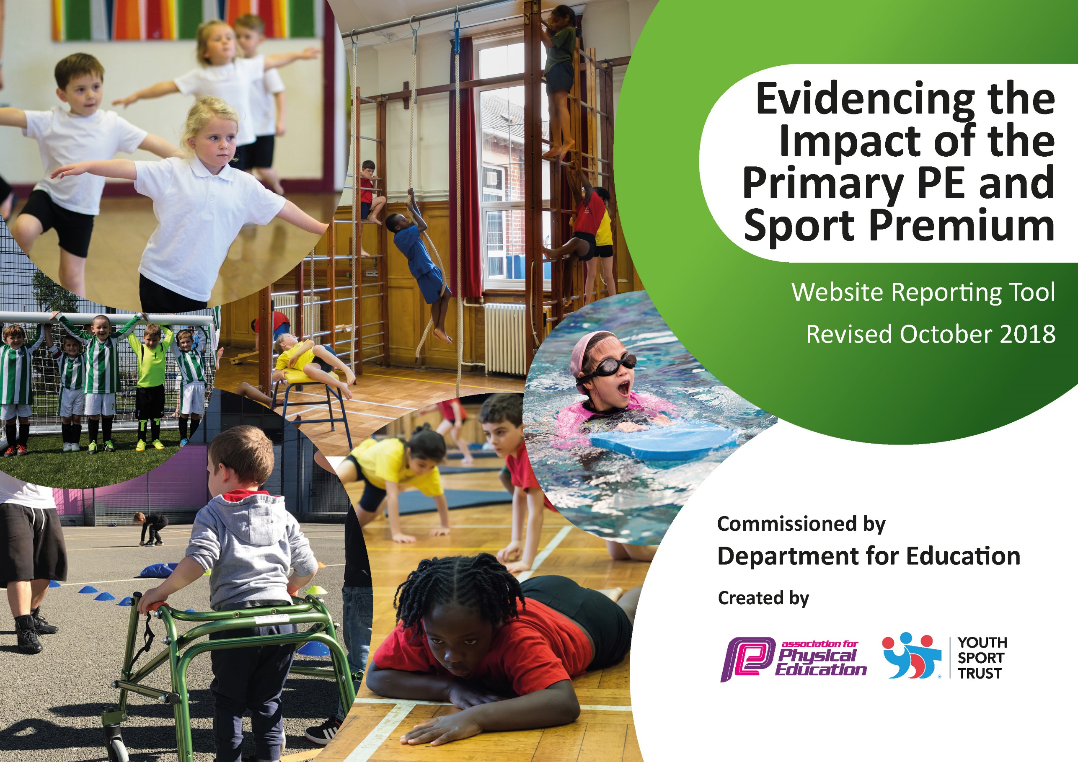
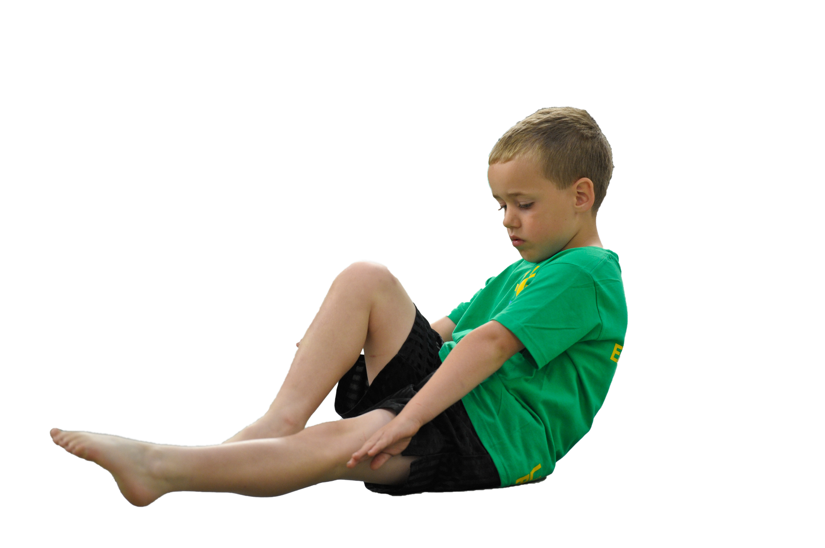
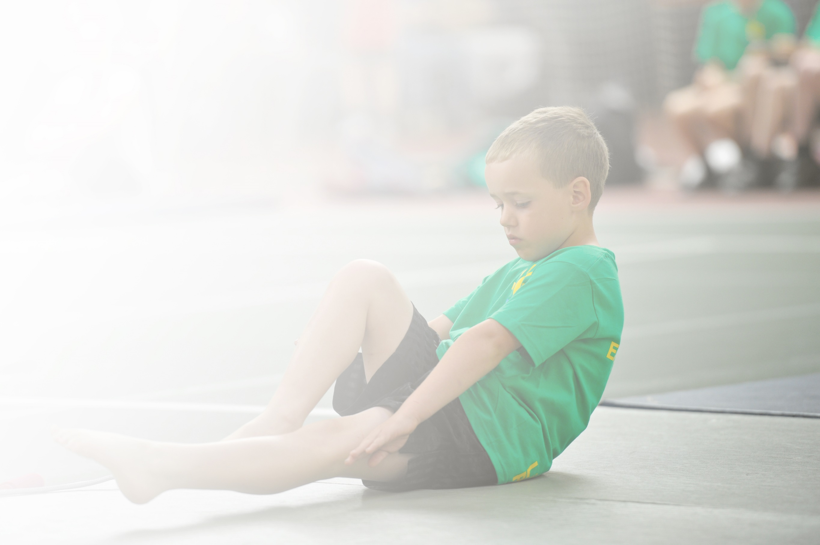
Schools must use the funding to make additional and sustainable improvements to the quality of Physical Education, Sport and Physical Activity (PESPA) they offer. This means that you should use the Primary PE and Sport Premium to:

- Develop or add to the PESPA activities that your school already offer
- Build capacity and capability within the school to ensure that improvements made now will benefit pupils joining the school in future years

Please visit gov.uk for the revised DfE guidance including the 5 key indicators across which schools should demonstrate an improvement. This document will help you to review your provision and to report
your spend. DfE encourages schools to use this template as an effective way of meeting the reporting requirements of the Primary PE and Sport Premium.

We recommend you start by reflecting on the impact of current provision and reviewing the previous
spend. Under the Ofsted Schools Inspection Framework, inspectors will assess how effectively leaders use the Primary PE and Sport Premium and measure its impact on outcomes for pupils, and how effectively governors hold them to account for this.

Schools are required to publish details of how they spend this funding as well as on the impact it has on pupils’ PE and sport participation and attainment by the end of the summer term or by 31 July 2019 at the
latest.
We recommend regularly updating the table and publishing it
on your website throughout the year, as evidence of your
ongoing review into how you are using the money to
secure maximum, sustainable impact. To see an
example of how to complete the table please
click HERE.

Support for review and reflection - considering the 5 key indicators from DfE, what development needs are a priority for your setting and your students now and why? Use the space below to reflect on previous spend, identify current need and priorities for the future.

Key achievements to date: | Areas for further improvement and baseline evidence of need:
Numbers of KS2 children using the trim trail at breaktimes and lunchtimes – promoting good health, hand-eye coordination, balance and agility.  Increase in staff confidence teaching PE following professional development with the sports coach.  There has been an increase in children across the school taking part in inter-school competition – (football, cross-country, golf, dodgeball and athletics)  The PE curriculum across school has been overhauled by the PE subject leader to bring it in line with the whole school. | Ensuring all children are engaged in at least 30 minutes of physical activity in school every day.  Ensuring the overhauled PE curriculum designed to marry with the school’s curriculum is being planned for and delivered.  Ensuring all children have access to ‘good’ or better teaching in PE.  Ensuring the children’s preferences re. sports and activities are included in the long term plan.  Increase competitive sporting opportunities across the MAC.

Meeting national curriculum requirements for swimming and water safety | Please complete all of the below:
What percentage of your current Year 6 cohort swim competently, confidently and proficiently over a distance of at least 25 metres?  N.B. Even though your children may swim in another year please report on their attainment on leaving  primary school. | 87% (27/31)
What percentage of your current Year 6 cohort use a range of strokes effectively [for example, front crawl, backstroke and breaststroke]? | 87% (27/31)
What percentage of your current Year 6 cohort perform safe self-rescue in different water-based situations? | 81% (25/31)
Schools can choose to use the Primary PE and Sport Premium to provide additional provision for swimming but this must be for activity over and above the national curriculum requirements. Have you used it in this way? | Yes/No

Action Plan and Budget Tracking
Capture your intended annual spend against the 5 key indicators. Clarify the success criteria and evidence of impact that you intend to measure to evaluate for students today and for the future.

Academic Year: 2018/19 | Total fund allocated: £ | Date Updated:
Key indicator 1: The engagement of all pupils in regular physical activity – Chief Medical Officer guidelines recommend that primary school children undertake at least 30 minutes of physical activity a day in school |  |  |  | Percentage of total allocation:
 |  |  |  | 51%
School focus with clarity on intended impact on pupils: | Actions to achieve: | Funding allocated: | Evidence and impact: | Sustainability and suggested next steps:
Sports coach employed during Tuesday and Thursday lunchtimes to engage pupils in physical activity. Targeted groups will, therefore, achieve the 30 minute of physical activity as well as serving to encourage children from other sections to join in.  PE subject leader to launch initiatives at engaging children in physical activity, including the dance club, a skipathon and sports day.  KS1 climbing frame – a permanent climbing frame to be sourced for key stage one children to use within PE lessons, breaktimes and lunchtimes, increasing the number of children active.  Purchase EYFS PE fundamentals equipment to enable reception children to engage in physical activity at breaktimes and lunchtimes, as well as to be used in PE lessons. | 12.00-12.30 – targeting KS1 girls identified as group missing out on the target physical activity per day.  12.30-13.00 – targeting LKS2 boys identified as a group missing out on the target physical activity.  Pupil survey to ascertain amount of children taking part/ engagement levels/ overall effectiveness.  Set up a regular dance club at lunchtimes to engage KS1 and KS2 children in physical activity.  Train dance leaders so that the children can lead and deliver the dance club themselves.  Organise an inclusive KS1 Sports Day, KS2 Sports Day and MAC Sports Day  Obtain quotes for engaging and effective climbing frame.  Put into place and demonstrate to teachers how they can use piece of equipment as an activity.  Create a list of essential equipment for EYFS: fundamentals such as balls, balancers and beanbags. | £1000  £1000 for PE leader TLR  £7000  £520 | Pupil survey shows children are highly engaged in physical sports.  Pupil survey shows children have a positive attitude towards sporting activities with physical activity being ranked highly as a favourite activity.  Children show high level of engagement in sports day. Exceptionally well attended.  Children take part in regular lunchtime dance activities.  Climbing frame / activity trail in place, promoting climbing and balancing skills of KS1 children. Children show a positive can do attitude towards new equipment.  GLD shows strong achievement in children’s physical skills. | Train up lunchtime supervisors to deliver next year.  PE subject leader will need release time to thoroughly plan these initiatives and deliver them across school.  Climbing frame will be subject to checks and guarantees about its durability.  Once children have been taught how to use safely, they will be able to use independently.  Survey numbers of children engaged.  Equipment to be purchased from a reputable company. Staff and children to be consulted on which equipment to be purchased.  Get feedback from staff and children about the effectiveness of the equipment.
Key indicator 2: The profile of PESSPA being raised across the school as a tool for whole school improvement |  |  |  | Percentage of total allocation:
 |  |  |  | 10%
School focus with clarity on intended impact on pupils: | Actions to achieve: | Funding allocated: | Evidence and impact: | Sustainability and suggested next steps:
PE subject leader to update the PE curriculum to bring it in line with the whole school focus, creating objectives for teachers to use in their planning – this should ensure engaging lessons for children, with depth and challenge that will link to their learning in other subjects.  PE subject leader and Sports Coach running whole school assessments during Autumn, Spring and Summer terms, These assessments will track progress and attainment in fundamental movement skills, providing staff with information to use in their assessments and to identify target groups of pupils falling behind.  The school is part of a network of local schools who share any curriculum updates, share good practice and stay abreast of any updates in the national picture. This will enable to PE subject leader to disseminate key information to the rest of the staff. This will ensure staff and children understand the importance of PE within Primary schools. | Create a LTP that plans for continuity and progression. Link the skills to the 6C curriculum being used within school.  Devise assessment tasks and how scores will inform assessments.  Share with staff so they understand how the assessments can inform their own teacher judgement.  PE subject leader to attend training run through the network, disseminating amongst staff during staff meetings. | £500 for PE subject leader TLR  £500 for SLT coach  £500 for PE subject leader TLR  £375 for membership of Dancedesk Network | Awareness of long term planning raised for staff members. Learning ladders in place for staff to implement. Objectives now linked to the 6C’s.  Children participate in sequential PE sports and activities. All children take part in 2 hours dedicated sports time each week – with the PE leader ensure lessons are objectively mapped to the wider curriculum.  Assessments carried out in balance, hand eye coordination, stamina. Lower year groups revealed issues with accuracy of hand eye coordination. Sports coach and PE subject leader closed the gap through CPD teaching. Year 5 and 6 gaps in stamina revealed through baseline. Cross country and athletics units covered to boost running for distance and stamina.  Through staff CPD, children have deeper subject knowledge and use assessment strategies devised by the network. Thus increasing children’s sporting skills. | The overhauled planning will be able to be used as long as the 6C curriculum is in use or when there is a new National Curriculum.  Assessments to be carried out termly and results to be tracked electronically. Staff can be taught how to carry out the assessments so that they are able to do their own classes in future.  PE leader to discuss effectiveness of network with SLT with a view to the future.

Key indicator 3: Increased confidence, knowledge and skills of all staff in teaching PE and sport |  |  |  | Percentage of total allocation:
 |  |  |  | 29%
School focus with clarity on intended  impact on pupils: | Actions to achieve: | Funding  allocated: | Evidence and impact: | Sustainability and suggested  next steps:
A professional sports coach from SLT to complete professional development with targeted teachers, developing pedagogy in PE and developing confidence. Higher quality teaching in PE with result in high quality outcomes for progress and increased attainment.  The PE subject leader will use management time to model lessons for other members of staff, sharing practice including differentiation and assessment. The subject leader will also use release time to work with identified class teachers, completing a thorough professional development journey. Higher quality teaching in PE with result in high quality outcomes for progress and increased attainment.  School is a member of the dancedesk network and will stay at the forefront of pedagogy developments in teaching PE that the PE subject leader will disseminate amongst staff. | Source a highly skilled sports coach.  Develop a coaching and mentoring programme for the Sports Coach to use with staff.  Monitor the effectiveness of the professional development through staff surveys.  Monitoring to be conducted to evaluate effectiveness and pupil progress.  Identify teachers to work with through staff surveys and informal monitoring.  Monitoring of pupil attainment to see if professional develop has an impact on children’s progress.  PE subject leader to update staff during staff meetings. | £3500 for coach to work both Tuesday and Thursday mornings throughout the year.  £1000 – to cover PE leader release time so that they can work with class teachers.  £375 to be a member of Dancedesk Network | Staff display greater confidence in the teaching of PE, with high quality lessons with improved teaching strategies.  Staff have developed subject knowledge with greater knowledge of challenge, assessment and strategies to improve children’s progress.  PE lead worked directly with staff to support planning, lessons and team teaching. PE lead worked with identified teachers to enable greater quality of teaching. Key Stage 2 teachers targeted: the impact being a higher quality of rigour in lessons.  Staff show increased impact through working with the PE lead, inspired by Dancedesk. Lessons include greater differentiation, giving children more opportunity for challenge and progress. | Staff to be upskilled.  Monitor lessons through informal observations – is teaching at least ‘good’?  Once staff have received professional development, they should be able to share their practice with others.  Monitor effectiveness through learning walks and data trawls.  Conduct staff surveys to ascertain teacher confidence.
Key indicator 4: Broader experience of a range of sports and activities offered to all pupils |  |  |  | Percentage of total allocation:
 |  |  |  | 1%
School focus with clarity on intended  impact on pupils: | Actions to achieve: | Funding  allocated: | Evidence and impact: | Sustainability and suggested  next steps:
Money put aside to purchase equipment to be purchased to open up new sporting opportunities. | Conduct pupil voice survey to identify sports and games they would like to play.  Source equipment. | £200 put aside for new equipment. | EYFS fundamental equipment purchased, athletics equipment purchased in line with child comments. Pupil voice showed touch rugby was desired - children enabled to use equipment and clubs went ahead. | Conduct a second pupil voice to see if equipment is being used/ engaged with.
Key indicator 5: Increased participation in competitive sport |  |  |  | Percentage of total allocation:
 |  |  |  | 11%
School focus with clarity on intended  impact on pupils: | Actions to achieve: | Funding  allocated: | Evidence and impact: | Sustainability and suggested  next steps:
Funding for travel to sports competitions and matches – this will enable the school to enter more competitions and increase participation  Subscription to BCSSA and Black Country School Games – being part of these network allows us to take part in a range of activities. Children will take part in a swimming gala, a football and cross-country competition in the summer. The aim is to enable a greater proportion of children in school to take part in inter-school competition.  Stadium booked to ensure all children can take part in a Sports Day at an Athletics stadium | PE subject leader to sign up for competitions and use taxis to transport a range of children to and from these activities.  Targeted groups of children to be chosen for a range of sporting opportunities – especially those children identified to have missed out last year.  All children to be invited to at least one of the Sports Days – MAC KS2 only. | £500 for taxis and coaches to attend sporting competitions  £100 to enter BCSSA  £50 to enter Black Country School Sports Partnership  £1400 for hire of Hadley Stadium over 3 days. | Children competed in cross-country, dodgeball, swimming, football competition and matches.  Children took part in competitions led by BCSSA. Including girls and boys swimming (10 children) swimming against children from across the Birmingham area.  Key Stage 1 sports day highly successful with high level of children’s engagement.  KS2 sports day cancelled due to stadium cancelling event – weather connected. Event will take place in Autumn 2019. | When funding is removed, paying for taxis will not be possible. There is the opportunity to fund raise to provide money in the future, however.  Enter both of these associations for 2019-2020 – set out diary early so that events can be planned longer in advance. Earmark children who could attend each event, ensuring a good mix of children and targeted groups receive opportunity to attend a competition.  When PPESP funding is removed, we will not be able to fund events at an external venue unless we fund raise.  We will hopefully be able to develop links with Q3 secondary school, which is next door, to negotiate use of their field so that we can still hold inclusive Sports Days.

